**This is my first Desktop-assembly.**

Material

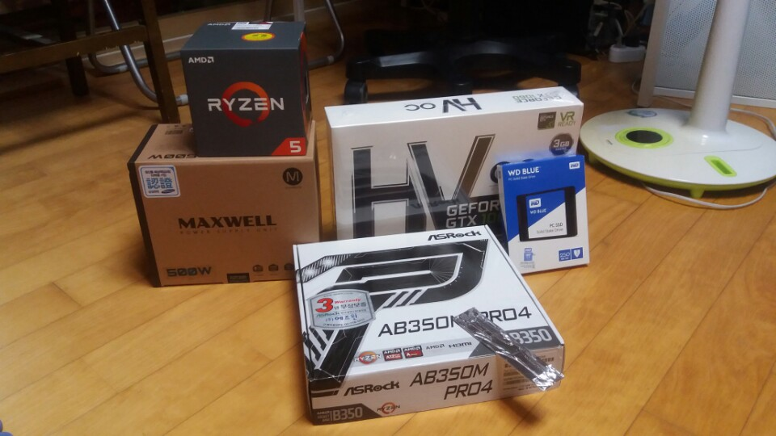

Cpu : RYZEN 1600

Main: ASROCK AB350M PRO4

Grapic: GTX 1060 OC 3G

RAM : DDR4 16G

SSD: 250G

POWER: MAXWELL 500W

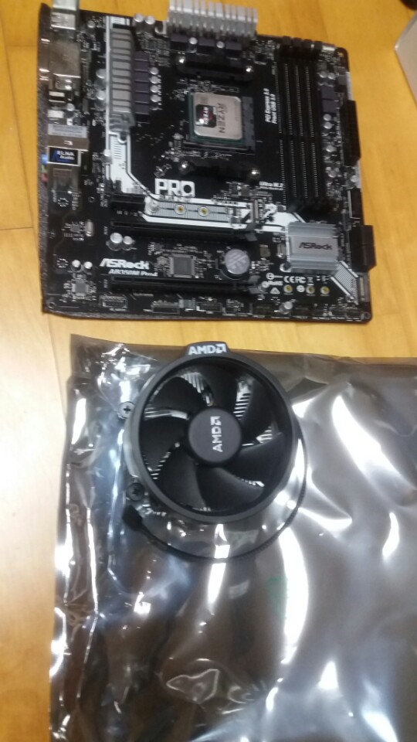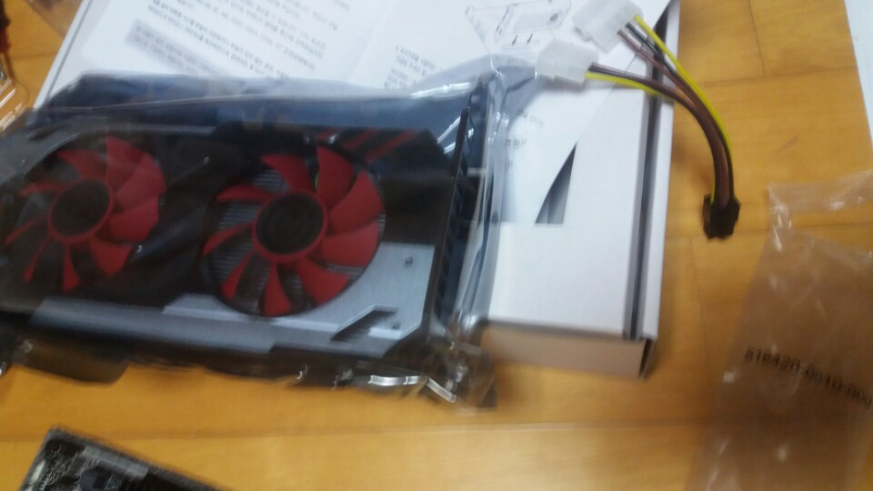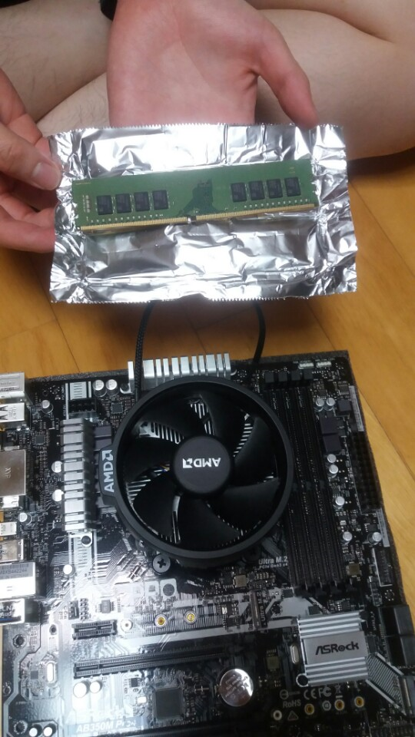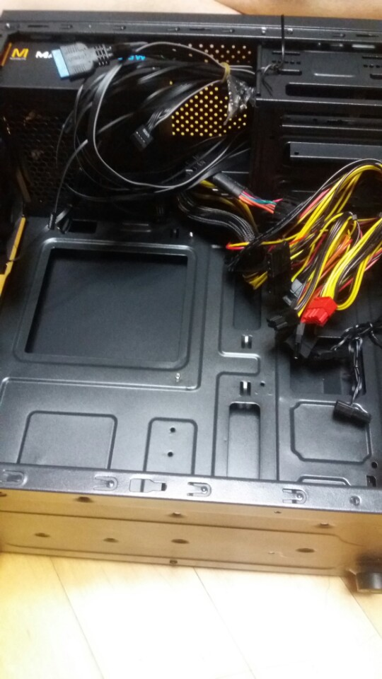

-------------------------------------------------------------------

Input Main-board.

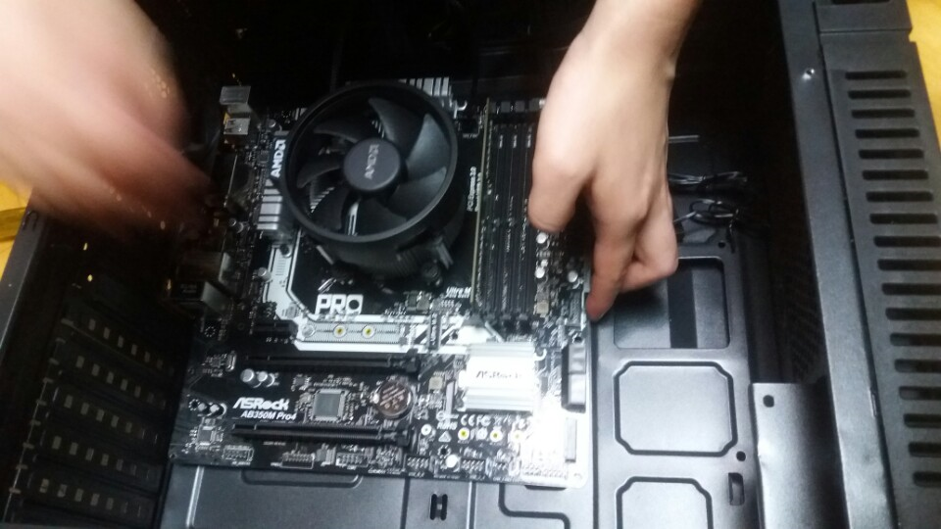

Input Grapic-card with Main-board.

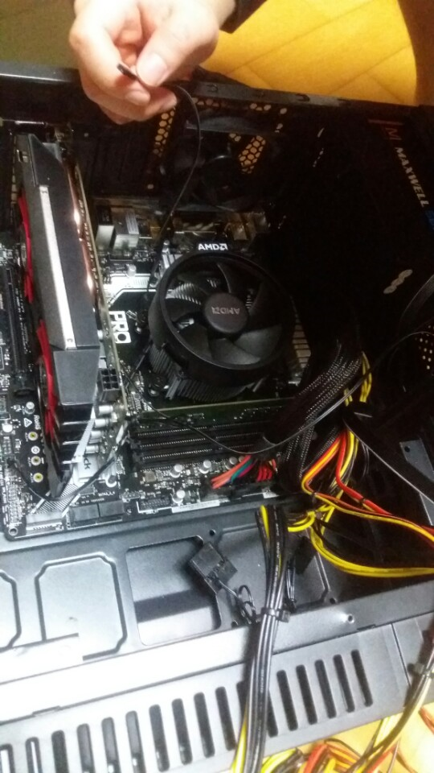

When you connect the line to Main-board, you should connect these lines.

First is **cpu-fan to Main-board (+others fan, if you want.)**

Second

**power-line to Main-board 2/ Grapic-card / SSD or HDD**

Third

**Line from computer-body to Main-board (USB 2.0 and 3.0/ 5 thin line like on my hand)**

Done

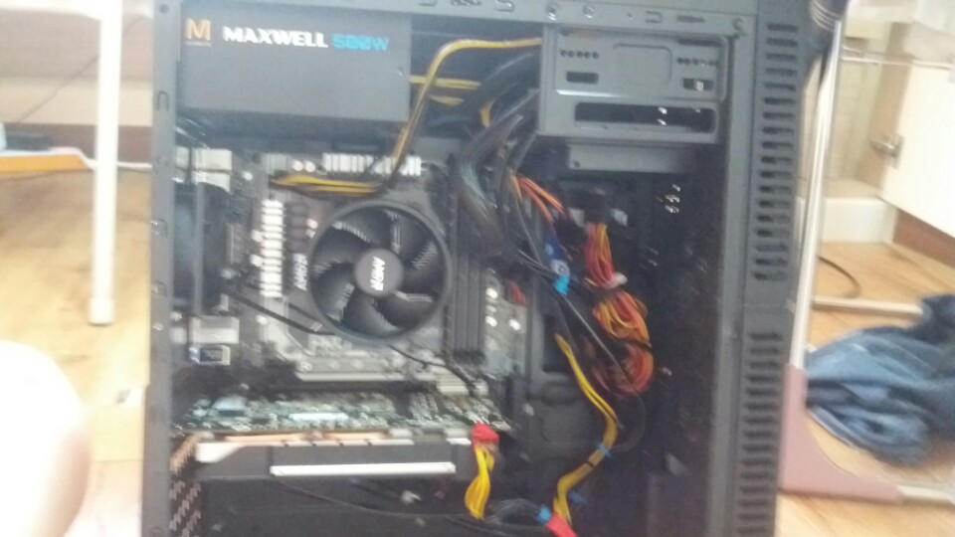

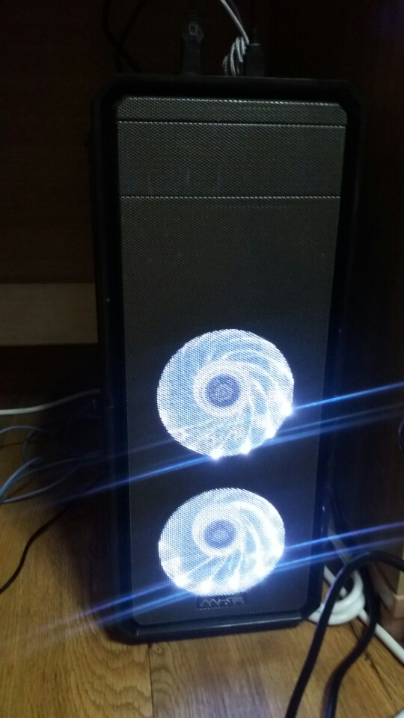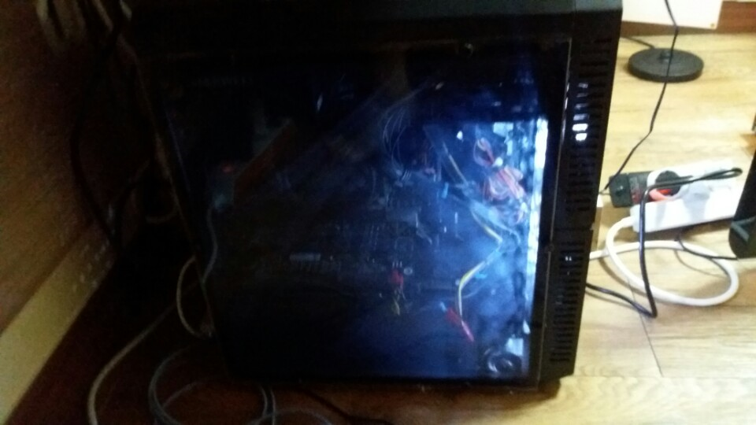

Play the game.

